1.IMPLEMENTING SINGLETON PATTERN

class Logger {

    private static Logger instance;

    private Logger() {

        System.out.println("Logger initialized.");

    }

    //method to get instance

    public static Logger getInstance() {

        if (instance == null) {

            instance = new Logger();

        }

        return instance;

    }

    //method for console(opt)

    public void log(String message) {

        System.out.println("LOG: " + message);

    }

}

public class Main {

    public static void main(String[] args) {

        //loggerinstance is got twice

        Logger logger1 = Logger.getInstance();

        logger1.log("First message");

        Logger logger2 = Logger.getInstance();

        logger2.log("Second message");

        // Checking for same object

        if (logger1 == logger2) {

            System.out.println("Both logger instances are the same.");

        } else {

            System.out.println("different logger instances");

        }

    }

}

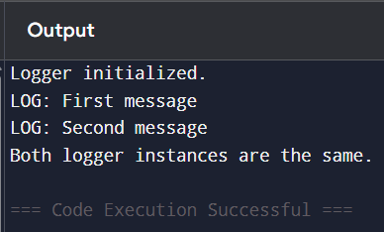**OUTPUT:**

2.IMPLEMENTING THE FACTORY PATTERN METHOD

//interface for documents

interface Document {

void open();

}

// Concrete classes for each of the document

class WordDocument implements Document {

public void open() {

System.***out***.println("Opening DOCX!!");

}

}

class PdfDocument implements Document {

public void open() {

System.***out***.println("Opening PDF!!");

}

}

class ExcelDocument implements Document {

public void open() {

System.***out***.println("Opening XLXS!!");

}

}

// Abstract class named as documentfactory

abstract class DocumentFactory {

public abstract Document createDocument();

}

// Concrete factories for separate type of document

class WordDocumentFactory extends DocumentFactory {

public Document createDocument() {

return new WordDocument();

}

}

class PdfDocumentFactory extends DocumentFactory {

public Document createDocument() {

return new PdfDocument();

}

}

class ExcelDocumentFactory extends DocumentFactory {

public Document createDocument() {

return new ExcelDocument();

}

}

// Main(Test)class

public class Main {

public static void main(String[] args) {

// Word Document

DocumentFactory wordFactory = new WordDocumentFactory();

Document wordDoc = wordFactory.createDocument();

wordDoc.open();

// PDF Document

DocumentFactory pdfFactory = new PdfDocumentFactory();

Document pdfDoc = pdfFactory.createDocument();

pdfDoc.open();

// Excel Document

DocumentFactory excelFactory = new ExcelDocumentFactory();

Document excelDoc = excelFactory.createDocument();

excelDoc.open();

}

}

**OUTPUT:**

